***Canteen Ordering System for Unilever***

Contents

1. ***Identifying stakeholders***
2. *Problem statement*
3. ***Objectives of the new Canteen Ordering System***
4. ***Process map***
5. ***Context Diagram of Canteen Ordering system* –**
6. ***Main features that need to be developed***
7. ***Write the in-scope and out-of-scope items for this software* -**
8. ***ER diagram of the system***
9. ***Business requirements***
10. ***Wireframes of the model***

* ***Identifying stakeholders*** **–**
* Upper management- Want to create Canteen ordering system for the employee.
* Employees- Order the food from the canteen.
* Canteen manager- Check the menu, create the menu, order for the food cook.
* Delivery boy- Deliver the food to the employee.
* Canteen staff- Cook the food, main the canteen.
* *Problem statement* **–**
  + - Employees don’t always get their choice of food.
    - Huge rush in the canteen during lunch hours resulting in employees wasting a lot of time waiting for tables to be vacant.
    - Large number of food waste.
    - Online order of food.
    - After 11pm order will not be accepted so that chefs can cook the food in proper quantity.
    - Delivery boy for the delivery of food at the place of employees.
    - Canteen manager maintains/change the menu.
* ***Objectives of the new Canteen Ordering System* –**
* Reduce food wastage by 30% within 6 months
  + Reduce canteen operating cost by 15%.
  + Delivering the food to the user's workstation, the canteen will be able to operate with lesser manpower.
  + Increase average effective work time by 30 minutes per employee per day.
  + Create online canteen ordering system.
  + Online delivery of food.
  + Reduce Food less than 15%
* ***Process map –***

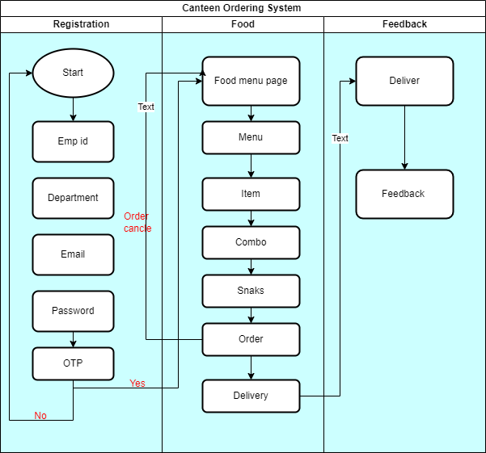

* ***Context Diagram of Canteen Ordering system* –**

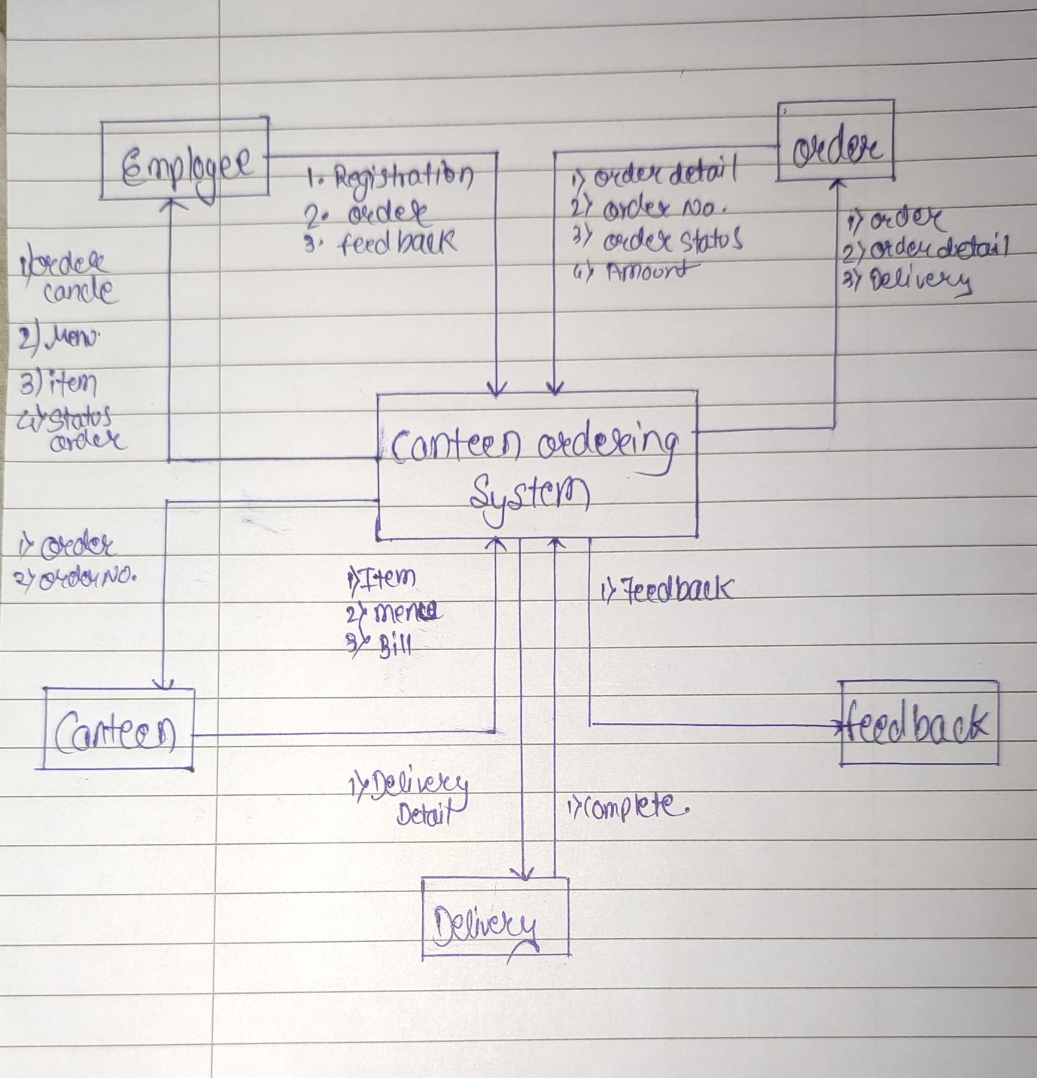

* ***Main features that need to be developed –***
* Online canteen ordering system app for the employees to order food for lunch.
* Order the food before 11 pm.
* Menu maintain by the Canteens manager.
* Canteen Manager inform to the chef to cook the food with the order quantity.
* Food delivery at the place of Employees.
* Online food ordering system help to reduce the food wastage.
* Employee shall order the food of their choice.
* After the 11pm order will not be accepted.
* Employee should be able to edit the items they want to order any time before checking out.
* Once the order is confirmed and the user has checked out, they should **not**be able to cancel or edit the order.
* ***Write the in-scope and out-of-scope items for this software* -**

* **IN Scope –**
* Employee should order the food.
* Only current employees can order the food.
* Menu of item.
* Timing for order the food.
* Feedback of food.
* Only the employees those work from office.
* Employee select the food from given menu.
* Amount will deduct from salary.

* **Out of Scope –**
* Other than Unilever employee is not able to order food.
* Work from employee can’t order the food.
* Order will not accept after time over of ordering food.
* Only menu food can order.
* Food can’t order on holiday’s.
* ***ER diagram of the system –***

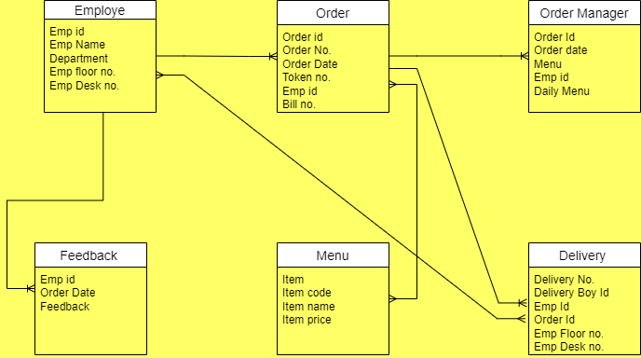

* ***Business requirements –***
* **Functional –**
* Creating and maintaining the program of Online ordering system.
* Order will close after 11pm.
* Once order checked out, will not able to edit or cancel the order.
* Canteen menu.
* Delivery boy will deliver the order.
* Payroll system for deduction of canteen amount from salary.
* Feedback.
* Canteen manager should change and update.

* **Non-functional -**
* The web pages should be light and render.
* The screens should be self-explanatory and very user friendly.
* Canteen ordering system is required to support a volume of 1500 employees ordering.
* Management would not want employees not ordering from the system as they cannot understand the screens and data fields on screen.
* We chose Java because it will not change much over time, and if we make it well, there will be very little maintenance to be done on the code.
* ***Wireframes of the model –***

